Software Specification

# Introduction

After having designed the machine, we were able to specify how our software should behave. We do be describing the software in a state machine with abstract states. This state machine also implements the different operation modes. After this we characterize the distinct inputs and outputs. We will convert the state diagram into a working UPPAAL model and explain the working systems in detail. Finally we explain the verification of our model. This document is called the software specification.

# Operation modes

Because the gyroscope is rather slow and has to stabilize, we have to wait for it to stabilize before we can sort the next disc, thus causing a bottleneck. If we want to sort very fast, we should skip the input from the gyroscope and sort the discs immediately after each other. Therefore, we want to implement 2 modes: a fast mode in which we don’t check for input from the gyroscope and thus don’t check if the disc actually reaches the tray, and a slower safe mode, where we check for input from the gyroscope and we can make sure that discs do reach the tray. Besides this, we want to make an additional incremental mode for debug purposes, in which the user has to press a button for the machine to sort the next disc.

# The State Machine

statemachine.png

The state machine in figure 1 defines the behaviour of the software. The three modes of our machine have been embedded into the figure. Black colored transitions are done in all modes. Green transitions only apply to the fast mode. Red transitions only apply to the incremental mode. Blue transitions only apply to the safe mode.

All symbols are inputs or outputs defined in the next chapter. However some symbols are not input or output but something else, these are documented here.

|  |  |
| --- | --- |
| Symbol | Description |
| TS | Starts a timer which increments variable "*t*" at a fixed time rate. |
| TR | Resets the timer by setting "*t*" to 0 |
| R | Reset button is pressed |
| FR | Full reset, reset of statistics and buttons variables |
| *t* | The variable containing the current timer value |
| *tdmax* | The maximum timer value after which it is decided that a disk was lost |
| *tavg* | The average time of a disk to get in the basket |
| *tgmax* | The maximum time it should take to stabilize the gyroscope. |
| *paused* | Variable indicating if the machine should go into the paused state or not. |

## Signals

**Inputs:**

**Color *c***: The input from the sensor with the following possible values: "*N"*, "*W*", "*B"* and *"U"*. The value "*N*" implies that no disk has been detected in front of the color sensor. The value "*W*" implies that a white colored disk is in front of the sensor. The value "*B*" implies that a black disk is in front of the sensor. Finally a value "*U*" means that an unknown disc is in front of the sensor.

**Motor *M***: The input from the motor can be that it is jammed, “*J*”, or that it is finished, “*F*”. We use these inputs as a method to detect if we can go to the next state, or to detect if there is a possible error.

**Abort *A***: This signal is high when the abort button has been pressed. This signal indicates that the machine should be halted nearly instantaneously and that the machine should enter the Abort state.

**Reset *R***: This signal is high when the Reset button has been pressed. The signal will be used to bring the machine back in its resting state and reset all the statistics about the current sorting operation.

**Start/Pause *S/P***: This signal is high when the Start/Pause button has been pressed. This signal will be used to start and pause the operation of the machine, depending on its current state.

**Gyroscope *G***: This signal might have three values "*L*", "*R*" and "*S*". "*L*" indicates that gyroscope is left, "*R*" indicates that the gyroscope is right and "*S*" indicates that the gyroscope is stable.

**Outputs:**

**Color Sensor *CS*** : Whether the color sensor is currently reading the sensor values. In order to read the values, a light from within the sensor has to be activated in order for the detection to work. This means that this light is an output for the machine. While the light is activated, the sensor is constantly reading the sensor values, but we only read it in certain situations. The color sensor is only active while the machine is in the operating state and is therefore disabled in the Resting state, Abort state, Finished state and the Paused state.

**Motor *M***: This signal has three possible values "*L*", "*R*" and "*O*". Where "*L*" is the motor moving to the left for 120 degrees, "*R*" is the motor moving to the right for 120 degrees, "*O*" is the motor turned off. The sorting arm moves, depending on the color read.

**LED Active *E***: The EV3 controller brick has a built-in LED behind the buttons that we can use to give feedback to the user. We can specify the flashing pattern from a limited set of patterns and we can specify the color. The LED will be emit a constant green color while the machine is in the Finished state. The LED will flash in red while it is in the Abort state. The LED will flash orange when it is in a warning state.

**Sound**: The brick also features a built-in speaker which we can use to give even more feedback to the user. We will use this speaker to play an error sound when the machine enters the Abort state. A sound will also be played when the machine enters the Finished state.

## Fast mode

The machine starts in a resting state. If the Start/Pause button is pressed in this state, the machine should go to the checking state. In this state, the machine checks which color disc is present on top of the light sensor. There are four different transitions the machine can make at this point, depended on the detected color. If the machine is black or white, it should go to a respective state in which the motor is rotated accordingly. When the motor has finished moving, the machine simply returns to the checking state. The machine can be paused by pressing the Start/Pause button anytime during the checking process. The machine then goes to a paused state as soon as it enters the checking state and waits for the Start/Pause again to return to the checking process.

## Safe mode

The safe mode is exactly the same as the fast mode, with a few additional safety checks. This means that it has the same assumptions according to the input. There is still an arrow from every state except the initial state to the abort state for when the ABORT button is pressed. There are two additional states. One for each color, black or white. After the motor is finished turning, it enters a state in which it waits for input from the gyroscope (G), which can indicate a disc that felt to the right (R) or to the left (L). When the input is correct, it goes to the state in which the color is checked. When the input is wrong (Exception) (wrong side, no input at all after a while), the machine goes to the exception state.

Incremental mode

The incremental mode is again almost the same as the safe mode, so again the same assumptions about the input and the state machine, but now there is 1 extra state between the ingoing arrows to the state in which the color is checked. In this state, the machine waits for a press on a button, the START/STOP button (S/P) to continue. If that button is pressed, it goes to the state in which the color is checked. All the ingoing arrow that were going to the color-check state are now going to the wait-for-button-press state. There is 1 exception for this. From the resting state, you go to the color-check state immediately after a press on the button. It would be silly if you would have to press that button twice for something to happen.

## 

## 

## UPPAAL model

A UPPAAL model consist of multiple systems that communicate over several channels. The systems in our UPPAAL model are Reinhard, our main system, along with several other peripheral systems such as the Motor, Buttons and ColorSensor. Our main system Reinhard looks like this:

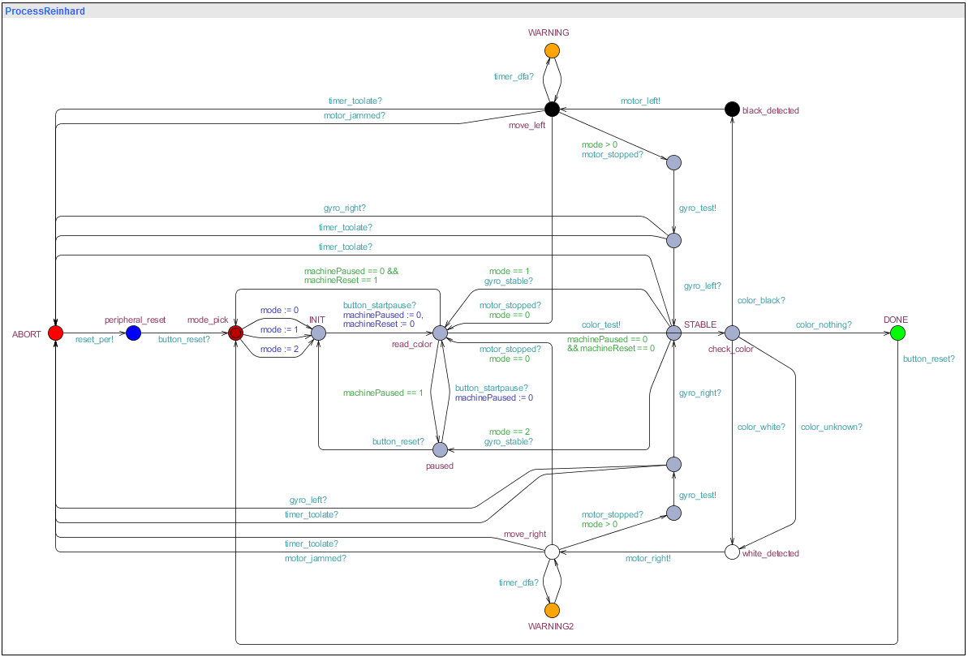

**Main process**

**Choosing the mode**

The initial state is *mode_pick*, which is not present in the state machine. In this mode one of the three operation modes is chosen. This is important for the verification process, because the UPPAAL model uses an internal variable to store the mode, whereas the state machine indicates the different modes with colors. If it is not possible to set tthis variable in the model itself, the verification process will only verify if a query holds for one mode.

**Initialization**

Upon choosing a mode in the *mode_pick* state, we enter the state *INIT*, which is equivalent to the initial state in the state machine. Here, the model waits for the *button_startpause* signal from *ProcessButtons*. Also, it sets the *machinePaused* and *machineReset* variable to 0, which ensures that the model does not immediately pause or reset.

**Reading colors**

Upon leaving the *INIT* state we enter the *read_color* state(*read* in the state machine). Whenever the *machinePaused* variable is 1 in the *read_color* state, the model goes to the *paused* state. If the *machineReset* variable is 1, the machine returns to the *mode_pick state*, but this has the lower priority. If both of these are 0, the *color_test* signal is send and the model transitions to the *check_color* state. In the *check_color* state it waits for a signal of the *ColorSensor* system depending on whether there is a disc and which color the disc has. Depending on the color, it goes to one of two parts of the main system, one for each distinct color(black or white). We will describe one of these parts as they are mirrored. Upon receiving the signal of a color, the model transitions to a *detected* state. Here, it sends a signal to *ProcessMotor* to start moving in the appropriate direction and goes into a *move* state. The transition the model makes here is dependend on the *mode* variable.

**Check sequence**

If mode is not 0, indicating that the system is in the safe or incremental mode, it will add a check sequence using the gyroscope. After the signal from the motor is received that it has stopped, the main system will send a test signal to the *GyroSensor* waiting for a signal back. If the correct signal is received back, indicating that the disc has arrived in the correct tray, it will return to *read_color* state. If mode is 0, indicating that the system is in fast mode, this check is skipped and the model returns to the *read_color* state from the *move* state as soon as it receives the *motor_stopped* signal from *ProcessMotor*.

**Finishing up**

When the model receives the *color_nothing* signal from *ProcessColorSensor*, the machine is finished and the model goes to the *DONE* state. Here it waits for the *button_reset* signal and returns to the initial state.

**Exceptions**

In our machine design is it specified that there is an ABORT button present that will stop the whole machine almost immediately. However, we have chosen not to include the abort button in our UPPAAL model as a possible transition for every state because this would be rather cumbersome and just a small implementation. We have however chosen to include possible exceptions such as a jammed motor or a signal that has not arrived in decent time. These transitions will lead the system into the ABORT state. In this state the process waits for the reset button to give a signal, after which it will reset the other processes and return to the mode selection state. Note that it is not required to actually reset the peripherals in the actual machine, this is only required in the UPPAAL model. Non-fatal exceptions are also represented in the model. Deviating average detection time is represented in the states *WARNING* and *WARNING2*, which the model reaches when the *timer_dfa* is send from *ProcessTimer*. Process *ColorSensor* can also send a *color_unknown* signal, which sends the machine to *WARNING3*. These warning states simply return to the state they were detected in and let the model continue.

**Subprocesses**

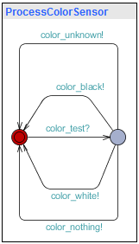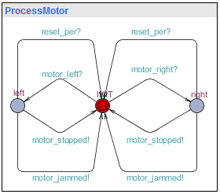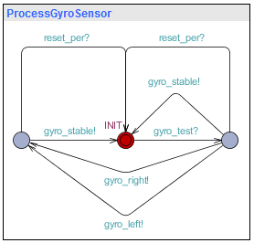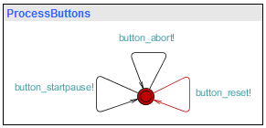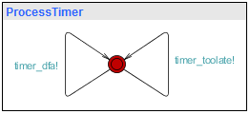

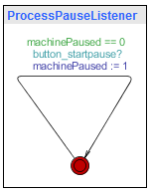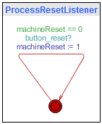

ProcessColorSensor waits for the *color_test* signal. It can then send four different signals: *color_black, color_white, color_unknown,* and *color_nothing*.

ProcessMotor waits for the *motor_left* or *motor_right* signal and moves to the respective state. From there, it can send either a *motor_stopped* or a *motor_jammed* signal. It also listens for a *reset_per* signal, after which it returns to the initial state.

ProcessGyroSensor waits for the *gyro_test* signal from the main process. It can then send the following signals: *gyro_stable*, *gyro_left* and *gyro_right*. If either *gyro_left* or *gyro_right* is send, the machine goes to an additional state where it is able to send a *gyro_stable* signal, indicating that the gyroscope has returned to its initial position. The process also listens for the *reset_per* signal, for resetting purposes.

ProcessButtons is continuously able to send *button* signals. This simulates that any button can be pressed at any time, which is necessary for the verifier to check all possible transitions.

ProcessTimer works the same as *ProcessButtons*, but with signals that an internal timer would send if it detected one of the errors.

ProcessPauseListener and ProcessResetListener continuously listen to the *button_startpause* and *button_reset* signals from ProcessButtons. When they detect the respective signals, they set the respective variables to 1 to alert the main process that the button is pressed.

# Verification

The main reason for recreating the state machine in UPPAAL was to allow extensive verification of the model. With UPPAAL we can verify the events like deadlock will never occur. The UPPAAL query language is a minimalistic but functional language to specify these properties. We use the following queries to verify our model:

## Abort state reachability

Query: E<> ProcessReinhard.ABORT

Description: The system can reach the ABORT state

We want to ensure that the machine halts in case of a fatal error. This check ensures that it is theoretically possible for a fatal error to occur and jump to the ABORT state.

## Abort state aviodability

Query: E[] not ProcessReinhard.ABORT

Description: There exists a path where the system does not reach the ABORT state

The machine should be able to run without ever encountering a fatal error.

## Peripheral reset

Query: A[] (ProcessReinhard.paused or ProcessReinhard.INIT) imply (ProcessMotor.INIT and ProcessGyroSensor.INIT)

Description: Whenever the system is in the paused or initialization state, the motor and gyro sensor must be in their initial state.

The goal is this check is twofold: We want to ensure that all peripherals are idle when the machine is in the paused state or has not yet started, and we have to be certain that after reaching the ABORT state, all peripherals are correctly reset. If we would leave the gyroscope in its left or right state, we would cause deadlock in the next cycle. Worse still, leaving the motor running after an ABORT could harm to machine.

## Full speed independent of gyroscope

Query: A[] mode == 0 imply ProcessGyroSensor.INIT

Description: When in full speed mode, the system must leave the gyroscope in its initial state.

Full speed mode is supposed to ignore the gyroscope to speed up the sorting process. Here we check if the machine correctly uses the mode setting.

## DONE state reachability

Query: E<> ProcessReinhard.DONE

Description: There exists a path where the system reaches the ABORT state

This check ensures that the machine can eventually finish the sorting process

## Machine pause justify

Query: A[] ((ProcessReinhard.paused and mode != 2) imply machinePaused==1)

Description: Whenever the system is in the paused state and not in incremental mode, machinePaused must be set to 1.

Verifies that in the full speed and safe modes, the machine only reaches the paused state when the pause button was pressed beforehand.

## Valid mode specified

Query: A[] mode==0 or mode==1 or mode==2

Description: mode must be one of: full speed, safe or incremental.

The mode value must be valid.

## No deadlock

Query: A[] not deadlock

Description: The system never deadlocks in any case

**Conclusion**

This document provided the information about the behavior of our software. We introduced our state machine diagram which we then implemented in UPPAAL. We clearly explained the working of our systems in UPPAAL and verified our model using this program. This part is used as the basis for the design of the software and is very important.